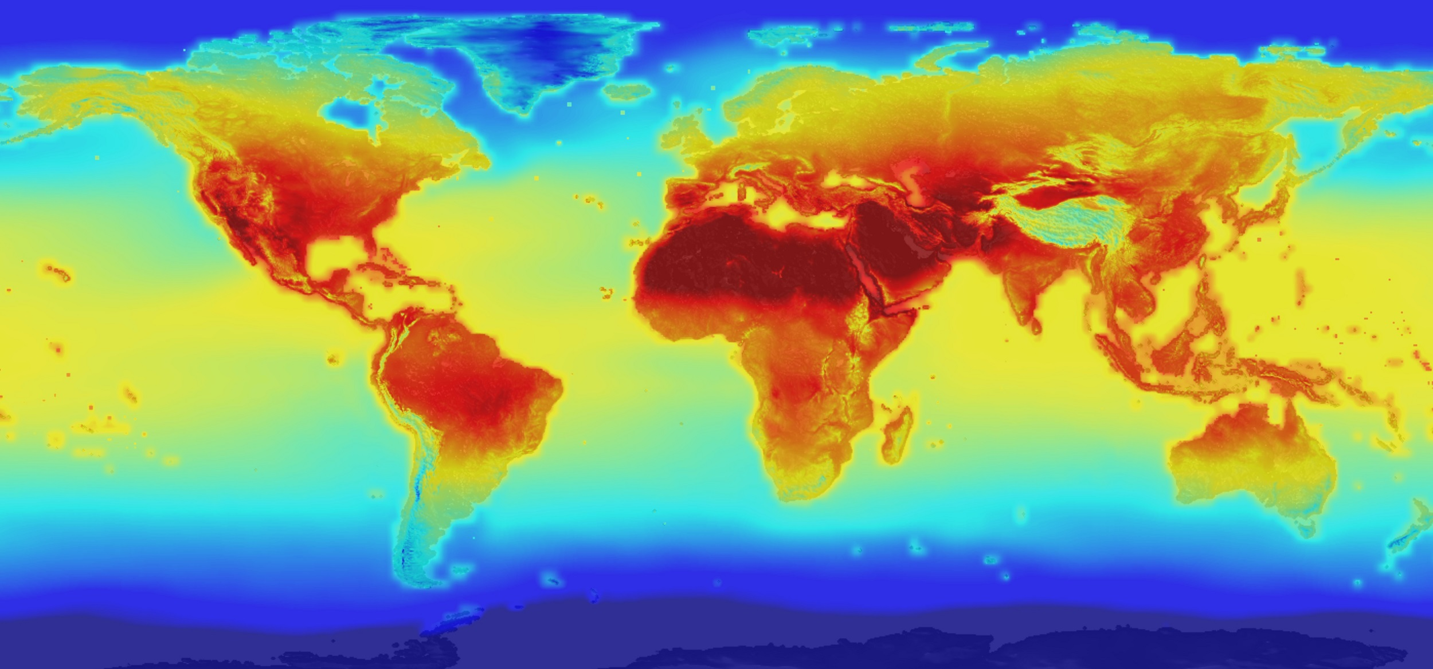

Image Source 1 - NASA Global Climate Study

Exploring Weather Trends

Comparing detroit with the world

James R. Small | DAND Project 1 | February 17, 2018

# Comparing Historic Temperature Trends

Observations

* Looking at the data on Detroit and Globally, the overall trend and ranges are similar.
* Based on the data, Excel linear trend (dotted) lines were created with similar results for both Detroit and Globally. A clear progression or increase in overall average temperature exists for both data sets.
* Pearson’s r for the Detroit data is .71
* Pearson’s r for the Global data is .74
* While initial Detroit temperatures from the mid-1700s start around half a degree lower, after about ten years Detroit’s average is for the most part higher. Within the two and a half century span, there are only two more decades and a brief multiple-year period where Detroit’s average dips below the global one.
* Compared with the global data, Detroit’s temperatures appear to experience more fluctuations. This is especially pronounced over the last 100 years.
* Zooming in to the 1980 – 2013 time range, there is steeper increase in temperature for both Detroit and Globally.
* Pearson’s r for the Detroit data within the range is .95
* Pearson’s r for the Global data within this range is .99

## Reproducability

1. From the Explore Weather Trends Project, [Accessing the Data with SQL Page](https://classroom.udacity.com/nanodegrees/nd002/parts/ca2cdcb3-c3df-428a-92e7-8b2630c7549d/modules/188c878c-5365-4bf3-9fa8-08cf57336fc4/lessons/dce89631-d141-4a36-b3fd-5e8ec038bc70/concepts/530f21c0-2f37-4390-aaab-3ce440e56d80):
   1. Find city – look for Detroit with the following SQL Query:

select * from city_list where city like 'D%'

* 1. Detroit is present – this is the closest major city to me, chosen as my City
  2. Retrieve data on Detroit with the following SQL Query:

select * from city_data where city = 'Detroit'

export to CSV

* 1. Retrieve global data with the following SQL Query:

select * from global_data

export to CSV

1. Load into Excel and Chart
   1. Load Detroit and Global CSV data into Excel spreadsheet
      1. Calculate 5, 10, and 20 year moving averages for both data sets.
   2. Examine data and select what to plot:
      1. Detroit temperature data ranges from 1743 - 2013 with missing data from 1746 - 1749
      2. Global temperature data ranges from 1750 - 2015 with no missing data
      3. Explore moving average temperature ranges of 5, 10, and 20 years. Based on data, chose moving average of 10 years.
      4. Using a 10 year moving average, the first possible date for Detroit is 1752, and Globally is 1759. Therefore the starting year selected is 1759.
      5. Again, with the 10 year moving average, the last possible date for Detroit is 2013 and Globally is 2015. Thus the ending year used is 2013.
   3. Create Detroit and Global temperature charts using scatter plots and line charts. Create these using original data, 5, 10, and 20 years moving averages to visualize the temperature distributions.
   4. Create Detroit vs. Global temperature line chart and refine – diagram included here.

## Sources

* [Microsoft Excel - Charts In Detail](https://www.safaribooksonline.com/library/view/microsoft-excel-/9781771371612/) (Used to get more in depth knowledge of charting in Excel)